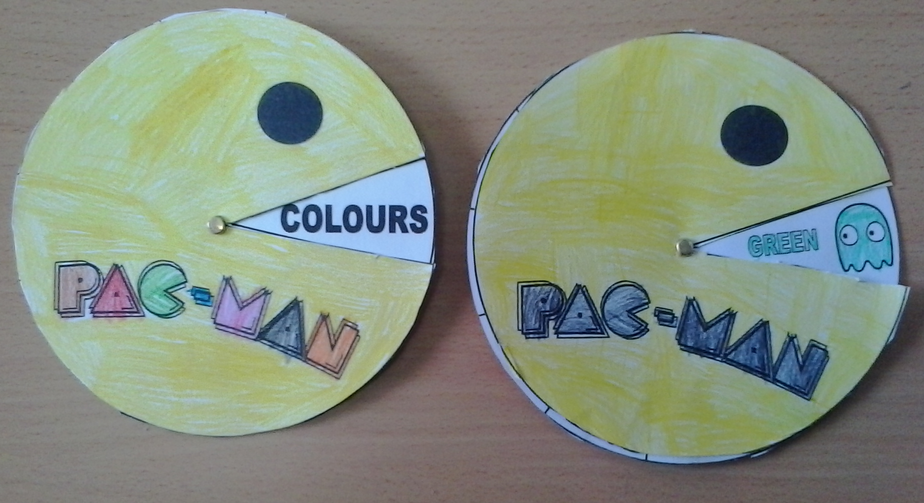
PAC-MAN EATS COLOURS

PAC-MAN EATS COLOURS
1.- PRINT THE WHEELS IN A-4 CARDBOARDS.
2.- COLOUR THE PAC-MAN IN YELLOW AND THE LETTERS OF THE COLOURS AND GHOSTS WITH THEIR COLOURS.
3.- CUT THE CIRCLES.
4.- USE A BRASS FASTENER TO ATTACH THE CIRCLES.
5.- PLAY WITH A CLASSMATE.
6.- SPIN THE GHOSTS WHEEL AND MAKE SENTENCES. WHAT COLOUR IS THIS GHOST? IT’S GREEN
