Escribe el enunciado del problema y resuelve

|  |  |
| --- | --- |
|  |  |
|  |  |
|  |  |
|  | Solución |
|  |  |

|  |  |
| --- | --- |
|  |  |
|  |  |
|  |  |
|  | Solución |
|  |  |

|  |  |
| --- | --- |
|  |  |
|  |  |
|  |  |
|  |  |
|  |  |

rincondelassonrisas.wordpress.com

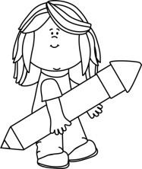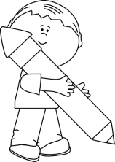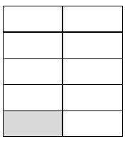 

 

rincondelassonrisas.wordpress.com