[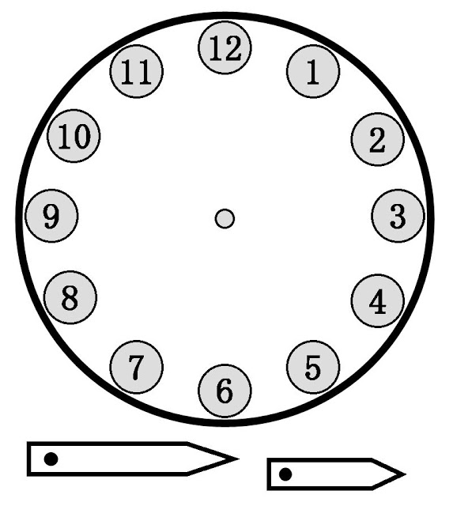](http://www.google.es/url?sa=i&rct=j&q=&esrc=s&frm=1&source=images&cd=&cad=rja&uact=8&ved=0ahUKEwi46_fTz6fLAhWCgBoKHdOtDvAQjRwIBw&url=http%3A%2F%2Fwww.imagui.com%2Fa%2Fcaricaturas-de-relojes-movibles-cG6rGagMX&bvm=bv.116274245,bs.2,d.d24&psig=AFQjCNG_OKCqT972INJALXyBF7eR3174xw&ust=1457200846168429)

