|  |  |
| --- | --- |
| DEL AL | |
|  |  |
|  |  |
|  |  |

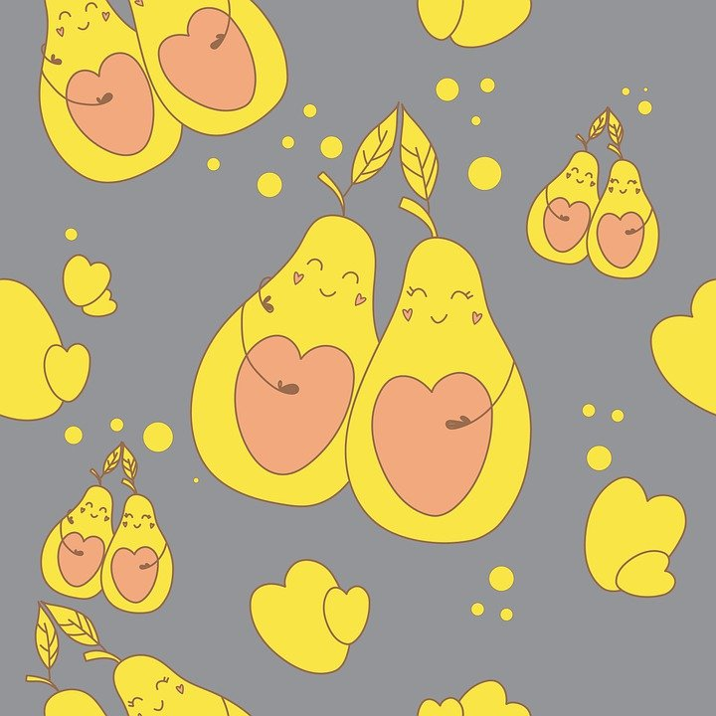

**Dobles y triples**

|  |  |  |
| --- | --- | --- |
| 189 x 2 | | |
|  |  |  |
|  |  |  |
|  |  |  |

|  |  |  |
| --- | --- | --- |
| 456 x 2 | | |
|  |  |  |
|  |  |  |
|  |  |  |

Maria Belén Cantos Albertos

CEIP Príncipe de Asturias

(ALMANSA –AB)

|  |  |  |
| --- | --- | --- |
| 245x 3 | | |
|  |  |  |
|  |  |  |
|  |  |  |

|  |  |  |
| --- | --- | --- |
| 364 x 3 | | |
|  |  |  |
|  |  |  |
|  |  |  |

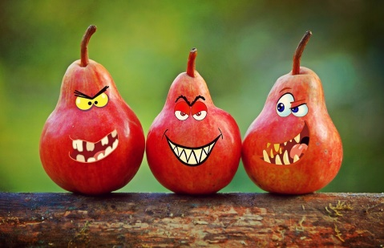

Fco Javier Gómez Jordán

CEIP Príncipe de Asturias

(ALMANSA –AB)