|  |  |
| --- | --- |
| DEL AL | |
|  |  |
|  |  |
|  |  |

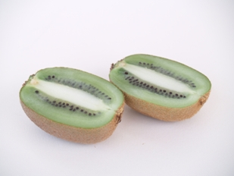

**mitades**

|  |  |  |
| --- | --- | --- |
| LA MITAD DE 348 | | |
|  |  |  |
|  |  |  |
|  |  |  |

|  |  |  |
| --- | --- | --- |
| LA MITAD DE 456 | | |
|  |  |  |
|  |  |  |
|  |  |  |

Maria Belén Cantos Albertos

CEIP Príncipe de Asturias

(ALMANSA –AB)

|  |  |  |
| --- | --- | --- |
| 765 : 2 | | |
|  |  |  |
|  |  |  |
|  |  |  |
|  |  |  |

|  |  |  |
| --- | --- | --- |
| 652 : 2 | | |
|  |  |  |
|  |  |  |
|  |  |  |

Fco Javier Gómez Jordán

CEIP Príncipe de Asturias

(ALMANSA –AB)

